

TDDC17

Artificial Intelligence

Lab 4

Cristopher Dahlström [crida498@student.liu.se](mailto:crida498@student.liu.se)

Jonathan Lundholm [jonlu159@student.liu.se](mailto:jonlu159@student.liu.se)

# Task 1

The chosen domain is: Shakey’s world.

The following assumptions for the world have been made:

* There is always one, and only one, light switch in each room
* Shakey kan push a box through a door without entering the room himself
* There is only one Shakey

## Objects and predicates

|  |  |  |
| --- | --- | --- |
| Objects and predicates | | Comment |
| ITEM | ?item | Small item that can be picked up |
| GRIP | ?grip | Griphook used to pickup items with |
| ROOM | ?room | Location |
| DOOR | ?room1 ?room2 | Connects two locations |
| WIDE-DOOR | ?room1 ?room2 | Connects two locations; can push boxes through it |
| BOX | ?box | Pushable object, required for turning lights on |
| in-room | ?room | Defines which room Shakey is in |
| box-location | ?room ?box | Defines the locations of a specific box |
| is-lit | ?room | Defines whether a room is lit |
| gripped-item | ?item ?grip | Defines whether an item is gripped |
| item-location | ?item ?room | Defines the location of an item |
| used | ?grip | Defines whether a gripper is used |

## Operators

|  |  |  |
| --- | --- | --- |
| Action | Properties | Comment |
| move | ?from ?to | Moves Shakey from one room to another |
| move_box | ?box ?from ?to | Moves a specific box from one room to another |
| turn_light_on | ?room ?box | Turns the lights on in a room if there is a box to stand on |
| turn_light_off | ?room ?box | Turns the lights off in a room if there is a box to stand on |
| grip | ?room ?item ?grip | Grips an item with a gripper |
| drop | ?room ?item ?grip | Drops an item with a gripper |

All operators except for switching the light on and off are self-explanatory. The prerequisite for being able to turn lights on or off is that Shakey stands on a box, but since switching the lights on or off always includes standing on a box, this functionality have been merged into the turn_light_on and turn_light_off actions.

# Task 2

The methodology for testing the performance is the following.

The initial test was done with a fairly small domain and set of goals that checks whether all different actions Shakey can perform are carried out correctly; this domain is then copied and connected.

For the second test another identical domain was added, with the same properties, connected to the already existing domains with a door; these two domains combine into a bigger domain with higher complexity. This procedure is repeated, thus forming our test-suite.

|  |  |  |  |
| --- | --- | --- | --- |
| Solver | Domain complexity | Steps | Time (sec) |
| FF | 1x | 14 | 0.00 |
| FF | 2x | 32 | 0.02 |
| FF | 4x | 50 | 0.10 |
| FF | 8x | 69 | 0.61 |
| FF | 16x | 143 | 5.63 |
| FF | 32x | 291 | 46.47 |
| FF | 64x | Out of memory | |
| IPP | 1x | 11 | 0.01 |
| IPP | 2x | 25 | 62.52 |
| IPP | 4x | Aborted due being +10 min | |
| Lama | 1x | 16 | 0.04 |
| Lama | 2x | Fails to run | |

One possible reason for how well the planners manage to handle the scaled up problems is how locally they work. Due to the structure, the added complexity still only adds new areas with similar problems, ergo, an ideal solver for this problem would solve the first part locally, move on to the next and solve that locally, and so on. Any solver that attempts to find an “ultimate solution” or a solution that ranges over all different parts of the area is bound to run into problems fast.

If plotting the table above, using a logarithmic scale (base 2), one sees that the time increase appears to be fairly linear; this is by no means surprising due to the reasoning about complexity above. Lama does not appear in the chart due to being unable to solve the problem at any other complexity than x1.

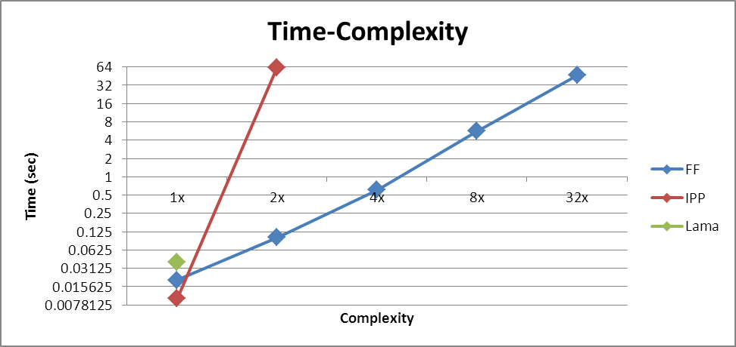

The following graph shows how the complexity relates to the number of steps required to solve the problem. If extrapolating straight lines from the FF and the IPP we notice that IPP seems to have slightly better solutions; this connects to the reasoning about the increased complexity as well; the planner solves the problem in a more optimal manner, at the cost of operating time, but due to this the complexity increases at a factor of 2, while the complexity of FF increases with a small factor, probably due to relying, to a greater degree, on heuristics and non-optimal solutions.

